Article

Spatial and temporal variability in oyster settlement on intertidal reefs support site-specific assessments for restoration practices

Shannon D. Kimmel1, Hans J. Prevost1, Alexandria Knoell1, Pamela Marcum1,2 and Nicole Dix 1,*

|  |
| --- |
| **Citation:** To be added by editorial staff during production.  Academic Editor: Firstname Lastname  Received: date  Revised: date  Accepted: date  Published: date    **Copyright:** © 2024 by the authors. Submitted for possible open access publication under the terms and conditions of the Creative Commons Attribution (CC BY) license (https://creativecommons.org/licenses/by/4.0/). |

1 Guana Tolomato Matanzas National Estuarine Research Reserve, Ponte Vedra Beach, FL 32082, USA;   
[Shannon.Dunnigan@FloridaDEP.gov](mailto:Shannon.Dunnigan@dep.state.fl.us) (S.D.K); [Hans.Prevost@FloridaDEP.gov](mailto:Hans.Prevost@dep.state.fl.us) (H.J.P.); [AKnoell@hotmail.com](mailto:AKnoell@hotmail.com) (A.K.)

2 Current affiliation: South Carolina Department of Natural Resources, Charleston, SC 29412, USA; [MarcumP@dnr.sc.gov](mailto:MarcumP@dnr.sc.gov)

**\*** Correspondence: [Nikki.Dix@FloridaDEP.gov](mailto:Nikki.Dix@dep.state.us)

**Abstract:** As some of the most productive ecosystems in the world, the declining condition and coverage of coastal habitats consequently results in the loss of the myriad economic and ecosystem services they provide. Due to variability in physical and biological characteristics across sites, increased place-based information to inform local management projects with the goals of reestablishing economic and ecological function of coastal habitats are imperative. Since oysters are often used in many restoration projects, this study quantified spatial and temporal patterns in eastern oyster spat settlement in a bar-built estuary in northeast Florida, USA that is host to a robust population of intertidal oyster reefs. Spat settlement was found to occur from April-November with small peaks in the spring and large ones around September. Inter-annual differences in spat settlement were likely influenced by existing environmental conditions and heavily affected by large-scale events such as tropical cyclones. Variations in regional spat settlements are possibly driven by the residence times of the watersheds, varying harvesting pressure, density of adult populations, and the location of the spat collectors. Results of this study illustrate place-based variability in oyster settlement patterns and underscore the importance of local monitoring for oyster resource management, restoration, and research.

**Keywords:** water quality, living shorelines, *Crassostrea virginica*, management, recruitment

1. Introduction

Coastal ecosystems are some of the most productive in the world providing numerous ecosystem services such as carbon sequestration, improvement of water quality, erosion control, and recreation [1, 2]. Recognizing their value and aesthetic, these ecosystems are subject to constant human activity which has ultimately led to the steady deterioration in many habitats (estimated anywhere between 30 – 85% loss) of these [1-7]. With the loss of these coastal habitats, the critical ecosystem services and economic value of those services decline as well, such has been seen in the number of viable (non-collapsed) fisheries (-33%), provision of nursery habitats (-69%), and filtering and detoxification services (-63%) [8]. The mitigation of anthropogenic effects is of significant need in these systems. As such, efforts in the restoration and enhancement of these habitats have increased with their decline in ecosystem and economic function.

The use of organic materials in these projects has additional benefits beyond mere construction material. Living shorelines, a form of natural stabilization using organic materials, have been found to improve water quality, cease or reverse coastal erosion, and serve as critical habitats for plants, fishes, and invertebrates [9-12]. One common type of living shoreline is a shellfish-based living shoreline [13-15] which has the advantages of adapting with a changing climate, such as oyster reefs being able to grow at the pace of sea level rise [16] and being able to self-repair after a destructive event [17]. Oysters have been established as ecosystem engineers and keystone species because they can maintain, modify, and form habitats [18, 19]. As such, oysters are an ideal target material in mitigation projects in ecosystems with previous or existing oyster reef habitats as often a primary or secondary goal of these installations is utilizing their gregarious settlement behavior to continue to form and strengthen these installations over time. This is especially important as the return-on-investment of oyster restoration projects varies widely and increases with project size [20].

Abundant and common to the southeastern United States, the eastern oyster *Crassostrea virginica* [21] forms three-dimensional reefs which can be intertidal or subtidal. In fact, it is the only reef building oyster in the state of Florida, USA [22]. These reefs enhance secondary and tertiary productivity within estuaries as juvenile fish and crustaceans recruit to and utilize these reefs as foraging grounds and refuge [23-30]. Additionally, oyster reefs provide other types of ecosystem services such as water filtration, prevention of coastal erosion, boat wake mitigation, and carbon sequestration [31-38]. They also have high intrinsic economic value and cultural importance as they have been harvested as a food source and mined for shell for many years [39-41, 22].

Eastern oysters are non-incubatory oysters, meaning they release gametes into the water column and fertilization occurs external to the organism [42]. Their larvae remain in the planktonic stage for about 2-3 weeks before settling on a suitable substrate, from which they are known as “spat” [43]. Many abiotic and biotic factors influence the timing and extent of spawning to the recruitment and survival of juvenile oysters. Temperature, salinity, and circulation patterns are amongst the most notable factors affecting oyster larvae, as well as food supply and turbidity which can affect the length of the larval period [44-47]. Field studies have shown that settlement and recruitment of oyster larvae often has high inter-regional and interannual variability [48-53]. Establishing oyster settlement patterns and understanding the effect of abiotic and biotic factors on settlement in regions with restoration goals is valuable in planning the timing of installation and success of many restoration projects. This is especially true for projects with the goals of forming a functional oyster habitat as part of their design and to maximize the rate of return on the installations given that restoration is often more successful with larger areas [20].

With the goal of informing oyster-based restoration and enhancement projects, the first objective of this study was to quantify spatial and temporal variability in oyster settlement in a dynamic, bar-built estuary in Northeast Florida, USA that is host to a robust population of intertidal oyster reefs. Given the variability of oyster settlement observed in previous field studies in the southeast United States, and often more studies of subtidal oyster reefs [51, 54-57], as well as differences in oyster densities in Northeast Florida [58, 59], it was expected that there would be spatial variability amongst study sites and over time. Therefore, potential drivers of this variability were also examined to provide further insight into differences amongst regions and years.

2. Materials and Methods

2.1. Study Sites

The Guana-Tolomato-Matanzas (GTM) estuary is a bar-built estuary with enclosed lagoons “rivers” (the Guana, Tolomato, and Matanzas) that trifurcate at the St. Augustine Inlet (Figure 1). This inlet is one of two in the system, and it is maintained and stabilized with a jetty by the United States Army Corps of Engineers to a depth of 5-m. The other, the Matanzas Inlet, is an unstructured inlet just north of Marineland, Florida, USA. The estuary is well-flushed with a short residence time of approximately 12.6 days [60-62] and is well-mixed. The GTM estuary hosts exceptionally intact and robust populations of eastern oysters that filter approximately 60% of the estuary’s volume within a single residence time [62]. There is also a functional oyster fishery (commercial and recreational) in several regions.

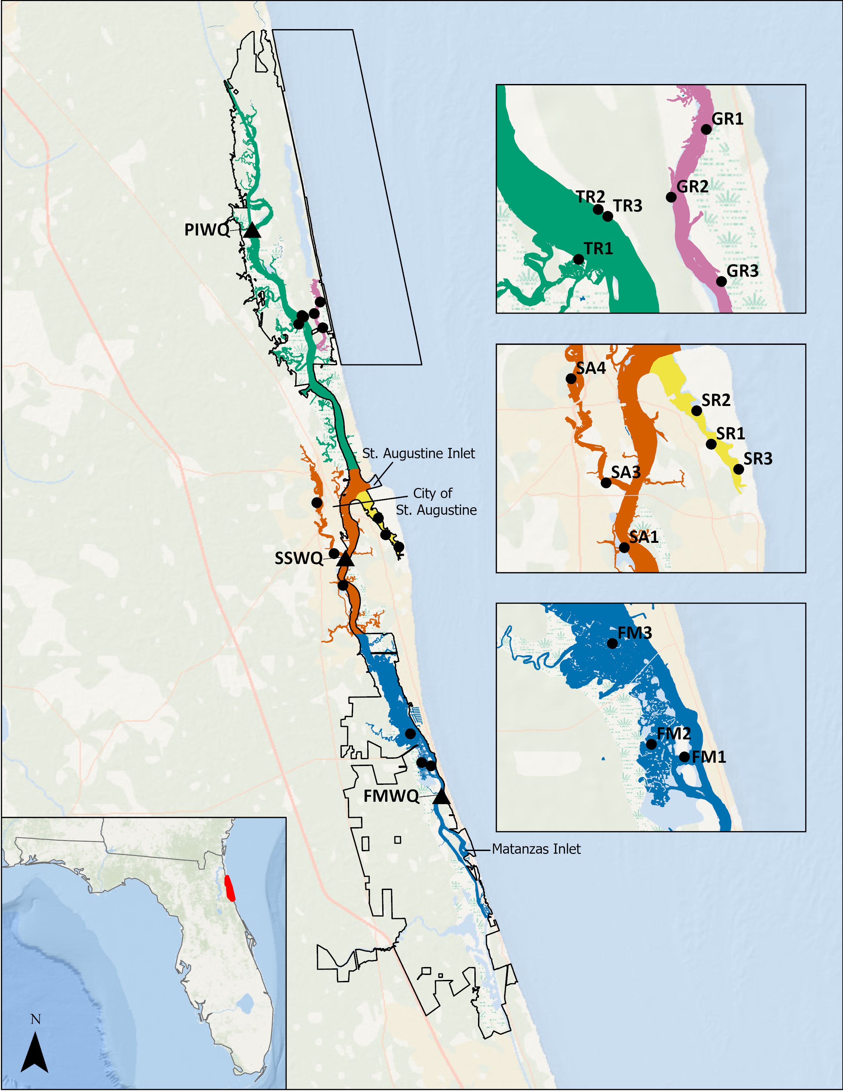

**Figure 1.** Map of the Guana Tolomato Matanzas National Estuarine Research Reserve boundary (black line, bottom inset: red), spat collector locations (black dots), water quality monitoring stations (black triangles, not included in insets), and regions: Tolomato River (turquoise), Guana River (pink), Salt Run (yellow), St. Augustine (orange), and Fort Matanzas (blue). Water quality stations are from the System-Wide Monitoring Program and are Pine Island (“PIWQ”), San Sebastian (“SSWQ”), and Fort Matanzas (“FMWQ”).

The GTM National Estuarine Research Reserve (GTMNERR) initiated a monitoring program for local oysters in 2014 in which a regional approach was adopted based on perceived differences in water quality, food availability, hydrodynamics, harvesting, and management [59]. Regions were created based on the major waterways along the Atlantic Intracoastal Waterway (ICW): Tolomato River, Guana River, Salt Run St. Augustine, and Fort Matanzas (Figure 1). Additionally, the GTMNERR maintains continuous long-term water quality monitoring stations within the GTM estuary as part of the System-Wide Monitoring Program (SWMP) of the National Estuarine Research Reserves (NERRS). Data from these stations were used to examine relationships in spat settlement with environmental conditions. All SWMP data are publicly available through the NERRS Centralized Data Management Office (CDMO) webpage [63].

2.2. Data Collection

2.2.1. Spat Tree Deployment

A stratified random sample of three reefs in each region of interest (except for the Tolomato River) were selected to deploy spat collectors. The Tolomato River region had two spat collectors deployed at either end of an oyster enhancement area known as Wright’s Landing, where 275 m2 of oyster reefs (28 individual reefs) were created from bagged shell in 2012 and 2013, and one across from the site on a natural reef. In June 2016 and June 2020, one additional spat collector was deployed in the St. Augustine and Tolomato regions, respectively.

Monitoring of larval settlement is commonly conducted by deploying substrate such as hanging oyster shell [64-68]. For this study, patterns in spat settlement were monitored using the hanging shell method in which samples were collected using T-shaped structures (trees) made from PVC, with shell “stringers” suspended from each side of the crossbar (Figure 2) [69-72]. Each stringer was composed of six cleaned eastern oyster shells that were between 5 to 10 cm in shell height. Holes were drilled through the shells, and they were strung onto galvanized wire oriented with the inner concave surface facing down. Prior to deployment, shells were cleaned by soaking in bleach water for 48 hours followed by removal of all fouling organisms by scrubbing with a wire brush. After bleaching, the shells were then soaked for at least 24 hours in freshwater as a rinse.

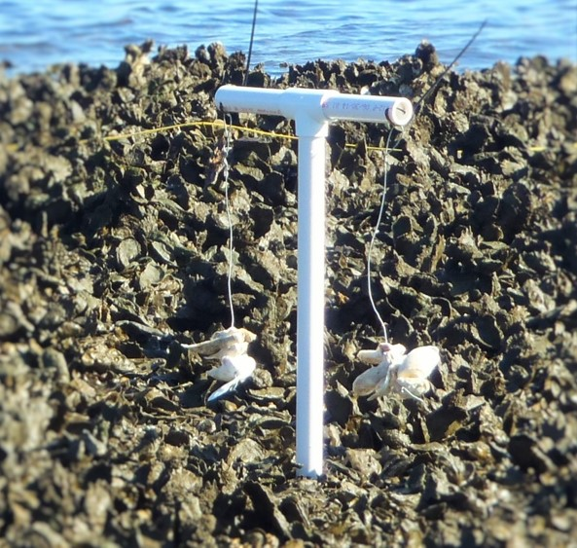

**Figure 2.** An example of a spat tree deployed on an oyster reef in the Guana River region of the Guana Tolomato Matanzas estuary in Florida, USA.

Trees were inserted into the reef at the apparent densest portion of live oyster on the reef and situated so that the shells were at the approximate height of the surrounding live oysters. All regions had trees deployed starting in February 2015 except for the Tolomato River, which was initiated in September 2015. These trees were left to soak for approximately one month upon which they were collected. During collection, any fouling organisms were removed from the tree, and new stringers were deployed. The retrieved stringers were labeled and stored in a -4°C freezer until processed. Efforts were made for the stringers to remain deployed for one month, however due to logistics, there was some variation in how long they were left in the field before collection. Trees were deployed for approximately 30 days on average with a range in the project of 21-43 days. Hurricane Matthew affected the study area in October 2016 and spat trees were unable to be collected, resulting in missing data from September and October of that year except for one tree (SA4) during September due to it being accessible by land. The longest deployment was during January 2017 and was due to logistics associated with access to the trees.

*2.2.2. Shell Processing and Counting*

Shells were assigned numerical IDs based on their position on each stringer, with the topmost shell designated number one and the bottommost number six. The top and bottom shells (one and six, respectively) were discarded and shells two through five were evaluated for spat abundance.

In early years of the monitoring, spat were counted using the naked eye or a magnifying glass on both sides of the shells (interior and exterior). A small-scale comparison study determined that spat abundance was significantly higher using a dissection microscope and there was no significant difference between total spat abundance per shell and spat abundance per shell on the inner surface only. Beginning in December 2017, all processing was done under microscope on the inner surface of the shells. A linear regression equation based on the comparison was developed to correct the non-microscope data for analysis:

|  |  |
| --- | --- |
| S = 1.4658*b* + 1.0378 | (1) |

where S was the adjusted number of spat counted and *b* was the observed number of spat counted on the inner surface of the shell by naked eye. Exterior counts of spat were not included in the analysis. The average number of spat per shell was calculated for each tree deployed within each region each month. These values were then rounded to convert the number of spat to integers.

2.3 Water Quality

Water quality data used in this study were downloaded from the CDMO for the Pine Island (PIWQ), San Sebastian (SSWQ), and Fort Matanzas (FMWQ) stations for the continuous water quality information (Figure 1) [73]. These stations were equipped with YSI EXO2 data sondes mounted to wooden pilings and deployed approximately one meter from the bottom. The sondes measured a variety of parameters every 15-minutes including water temperature (°C), salinity (psu), and turbidity (NTU). Discrete water samples were collected in duplicate at these same stations once a month for chlorophyll *a* (chl-*a,* µg/L*)* on a morning ebb tide from as close to the sonde depth as possible. Samples were filtered in the field, placed on ice in the dark and shipped overnight to the Florida Department of Environmental Protection’s Central Laboratory in Tallahassee, FL. Chl-*a* was extracted from frozen filters within 28 days and analyzed using spectrophotometry (SM10200H) [74].

Data quality checks were applied using CDMO methods [73] and data flagged as “rejected” and “suspect” were removed from the dataset for analysis. The duplicate chl-*a* samples from each station were averaged by month. All water quality data was then further aggregated inside and outside the defined spat settlement periods for descriptive statistics.

2.4. Data Analysis

All data analysis and visualizations were created using R programming language [75]. Several helpful import, filtering, and aggregating functions from the SWMPr package in R were used for the compilation of the water quality data [76].

Since oyster count data has been shown to fit a negative binomial distribution, a generalized linear regression model with a negative binomial distribution was used to compare for differences in spat settlement by region and across years [57, 77]. Spat counts per shell were assumed to be related to the amount of time they were left “soaking” during deployment. To control for this, the number of soak days was included as an effort offset (log link function) [78]. This causes the models to predict the count per deployment while maintaining the dependent variable as an integer of counts. The dependent variable was the average spat count for each collector rounded as an integer. The independent variables (main effects) were both categorical: region and year. Multiple models were fitted to the data: Model 0 was the intercept only, Model 1 included region, Model 2 included region and year, Model 3 included the interaction of region and year, and Model 4 included just year (Table 1).

Comparisons were made between models with different combinations of independent variables using Akaike’s Information Criterion (AICc). The lowest AICc value represents the best fit of the models tested (Table 1) [79]. Models were fit to the data using the glmmTMB package [80], assessed with the performance and DHARMa packages [81, 82] and predicted values (marginal means) and pairwise comparisons with Tukey adjustments were made from the best fit model using the emmeans [83] package in R. The default glmmTMB optimizer (nlminb) was used. All data visualizations and summaries were performed using tidyverse functions in ggplot2 [84] and dplyr [85].

3. Results

3.1. Spatial and Temporal Variability in Spat Settlement

Annual peak settlement shifted from May/June in 2015 to September in 2017, which continued for the remainder of the monitoring (Figure 3). Timing of minor peaks appeared to forecast peak abundance: reefs with minor peaks that occurred later in the spring had higher spat abundance both during the fall peak as well as annually (Figure 3).

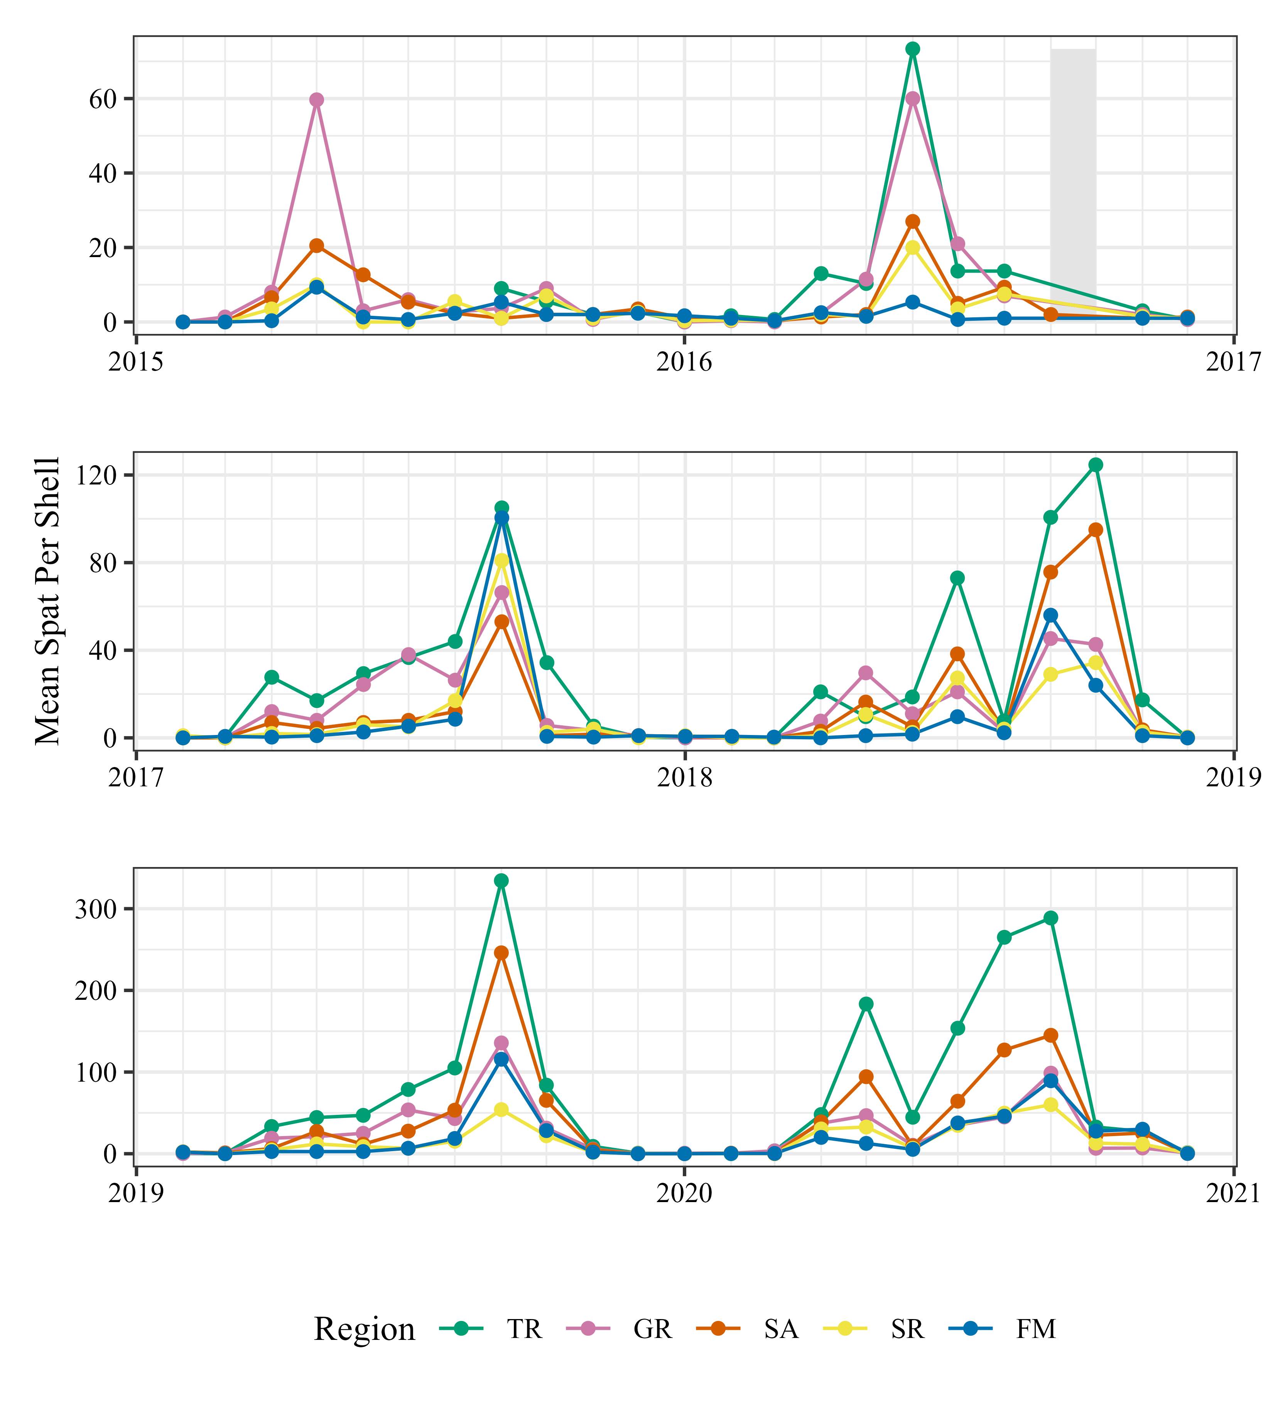

**Figure 3.** Monthly mean spat per shell for each region from 2015-2020 with panels broken up in two-year segments: Tolomato River (TR, green); Guana River (GR, pink); Saint Augustine (SA; orange); Salt Run (SR, yellow); and Fort Matanzas (FM, blue). Note the difference between the scales of the y-axis and missing data in September and October 2016 indicated by the gray box in upper panel.

Five different models were fitted to the spat per shell data (Tables 1 and A1). The best fitting model included terms for region and year. The dispersion ratio from the negative binomial distribution was 1.527 (*p* < 0.001), suggesting overdispersion. No significant interaction was found between year and regions. Autocorrelation in the residuals was mixed (Kolmogorov-Smirnov test: *p* = 0.034, Durbin-Watson test: *p* = 0.9353) and no adjustment was made. Since the model results found significant patterns in region and year, comparisons were made using estimated marginal means and Tukey’s post-hoc tests to identify where those differences were found in the levels of each factor (Tables A2 and A3).

**Table 1.** Model selection table for generalized linear models of spat count data including number of parameters (k), AICc value, the difference in AICc value of each model from the model with the lowest AICc (ΔAICc), and weight applied to AICc (AICc weight). Models are listed in increasing order of AICc.

|  |  |  |  |  |  |  |
| --- | --- | --- | --- | --- | --- | --- |
| **Model** |  |  | ***k*** | **AICc** | Δ**AICc** | **AICc weight** |
| Model 2: spat_count ~ region + year + offset[log(soak_days)] |  |  | 11 | 6484.63 | 0.00 | 1 |
| Model 3: spat_count ~ region + year + region:year +  offset[log(soak_days)] |  |  | 31 | 6504.43 | 19.81 | 0 |
| Model 4: spat_count ~ year + offset[log(soak_days)] |  |  | 7 | 6559.31 | 74.69 | 0 |
| Model 1: spat_count ~ region + offset[log(soak_days)] |  |  | 6 | 6613.63 | 129.00 | 0 |
| Model 0: spat_count ~ offset[log(soak_days)] |  |  | 2 | 6688.57 | 203.94 | 0 |

Tolomato River (TR) had the greatest mean spat per shell (untransformed mean: 43.11) and Fort Matanzas (FM) the least (9.97) (Figure 4A; Table 2). Variability in counts was also higher in the TR region than all other regions. There was no difference found between Guana River (GR) and St. Augustine (SA; p = 0.916) and settlement in these regions was higher than in Salt Run (SR) and FM (Figure 4A).

Spat settlement increased in all regions across the study period (Figure 3; Figure 4B). Between the first year (2015) to the final year of the study (2020), there was a 77.58% increase in the mean number of spat per shell (p < 0.0001; Table 2). Both 2015 and were significantly lower than all the other years (p < 0.0057; Figure 4B). The following two years 2017 and 2018 were higher, though not different from one another (p = 0.2745). Lastly, the final two years of the study, 2019 and 2020, had the highest average counts per shell (30.76 and 40.01, respectively).

**Table 2.** Estimated marginal means (EMM, log scale) of spat per shell. Results for regions were averaged over the levels of year and results for years were averaged over the levels of region. SE = standard error, CI = 95% confidence interval.

|  |  |  |  |  |
| --- | --- | --- | --- | --- |
|  |  | **EMM** | **SE** | **CI** |
| Region | Tolomato River | 3.33 | 0.13 | 3.09 – 3.58 |
| Guana River | 2.77 | 0.12 | 2.54 – 3.00 |
| St. Augustine | 2.63 | 0.12 | 2.39 – 2.86 |
| Salt Run | 2.08 | 0.13 | 1.83 – 2.34 |
| Fort Matanzas | 1.91 | 0.12 | 1.68 – 2.14 |
| Year | 2015 | 1.57 | 0.16 | 1.25 – 1.88 |
| 2016 | 1.73 | 0.14 | 1.44 – 2.01 |
| 2017 | 2.41 | 0.13 | 2.15 – 2.66 |
| 2018 | 2.79 | 0.13 | 2.55 – 3.04 |
| 2019 | 3.22 | 0.13 | 2.98 – 3.46 |
| 2020 | 3.56 | 0.12 | 3.31 – 3.80 |

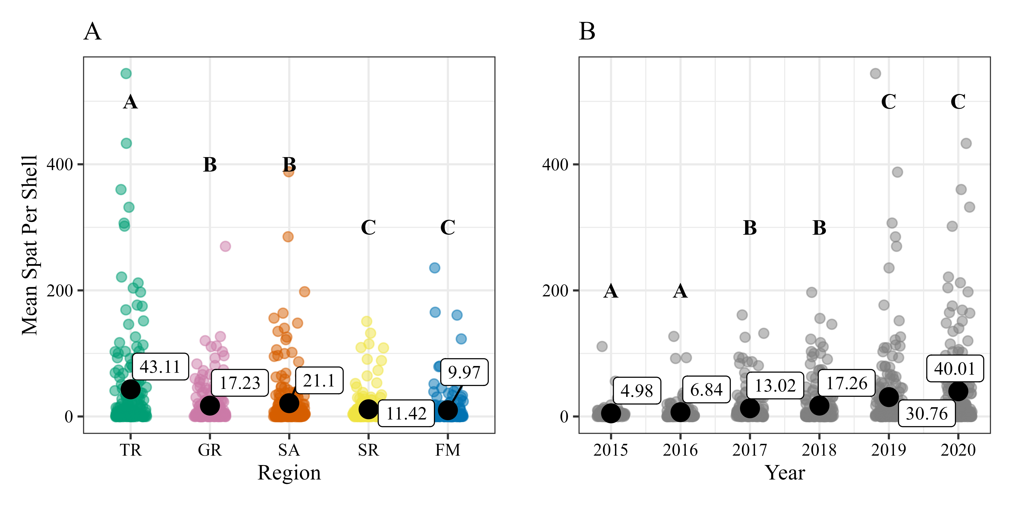

**Figure 4.** Mean spat per shell in the five regions (panel A) of the Guana Tolomato Matanzas estuary: Tolomato River (TR, green); Guana River (GR, pink); Saint Augustine (SA; orange); Salt Run (SR, yellow); and Fort Matanzas (FM, blue). Mean spat per shell in all regions for each year (panel B) of the study. Group means (raw and untransformed) are represented by the large black dots with the mean value presented in a call-out box next to the dot. Each smaller point represents the monthly means per spat tree between 2015-2020. Letters indicate Tukey’s post-hoc test results and years/regions with differing letters are significantly different from each other (*p* < 0.001).

3.2. Patterns in Annual Spat Settlement

Overall, spat settlement appears to occur in all regions in the GTM estuary between April and October (Figure 5). Typically, a minor peak in settlement occurs in the mid-late spring and a larger and regular peak occurs in September. All regions have more spat settlement between April – October than outside of this period (Table 3). For most regions, there is over 180% difference between spat settlement inside and outside of the settlement period. FM has the smallest difference with 313 (se = 110) average spat per year inside the settlement period and 26 (se = 14) outside the settlement period, but this difference is still well over 100%.

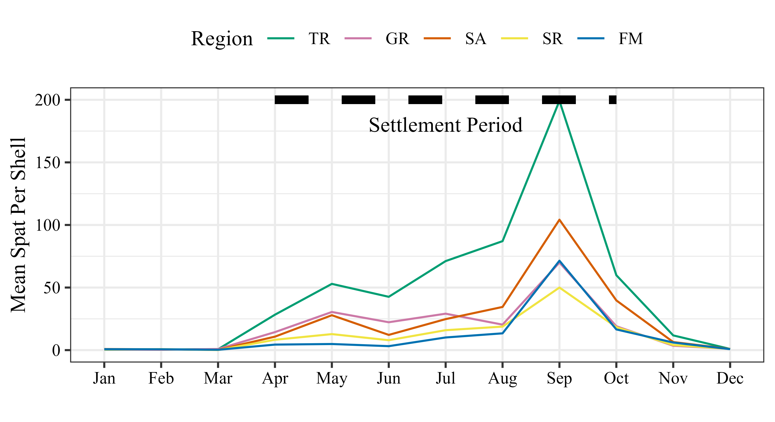

**Figure 5.** Monthly mean spat per shell with settlement period indicated as the thick dashed line between April and October for the five regions in the Guana Tolomato Matanzas estuary: Tolomato River (TR, green); Guana River (GR, pink); Saint Augustine (SA; orange); Salt Run (SR, yellow); and Fort Matanzas (FM, blue) based on data collected from 2015-2020.

**Table 3.** Summary information for spat settlement per shell by region inside the annual settlement period (April – October) and outside of the settlement period (January – March and November – Dec). Metrics include average total settlement per shell per year (standard error) and average settlement per shell (standard error).

|  |  |  |  |  |
| --- | --- | --- | --- | --- |
|  | ***Avg. Total Settlement***  ***Per Shell Per Year*** | | ***Avg Settlement***  ***Per Shell*** | |
| **Region** | **Inside** | **Outside** | **Inside** | **Outside** |
| Tolomato River | 1234 (466) | 38 (13) | 75 (10) | 3 (1) |
| Guana River | 571 (18) | 18 (5) | 29 (4) | 2(1) |
| St. Augustine | 677 (249) | 27 (11) | 35 (6) | 2(1) |
| Salt Run | 305 (100) | 16 (5) | 19 (4) | 2(1) |
| Fort Matanzas | 313 (110) | 26 (14) | 17 (4) | 2(1) |

3.3. Drivers of Variability

Average monthly water temperatures were relatively consistent from year to year and among stations except for a cold snap in the winter between 2017 and 2018 (Figure 6A). At PIWQ in the Tolomato River, salinity was generally lower and turbidity was generally higher than at the other two stations (Figures 6B and 6C). Salinities were lowest at all stations in the fall of 2017 (Figure 6B). At FMWQ and SSWQ, turbidity appeared to be higher in 2017 and 2018 compared to other years (Figure 6C). Chl-*a* was variable but generally highest in the warmer months at all stations (Figure 6D).

**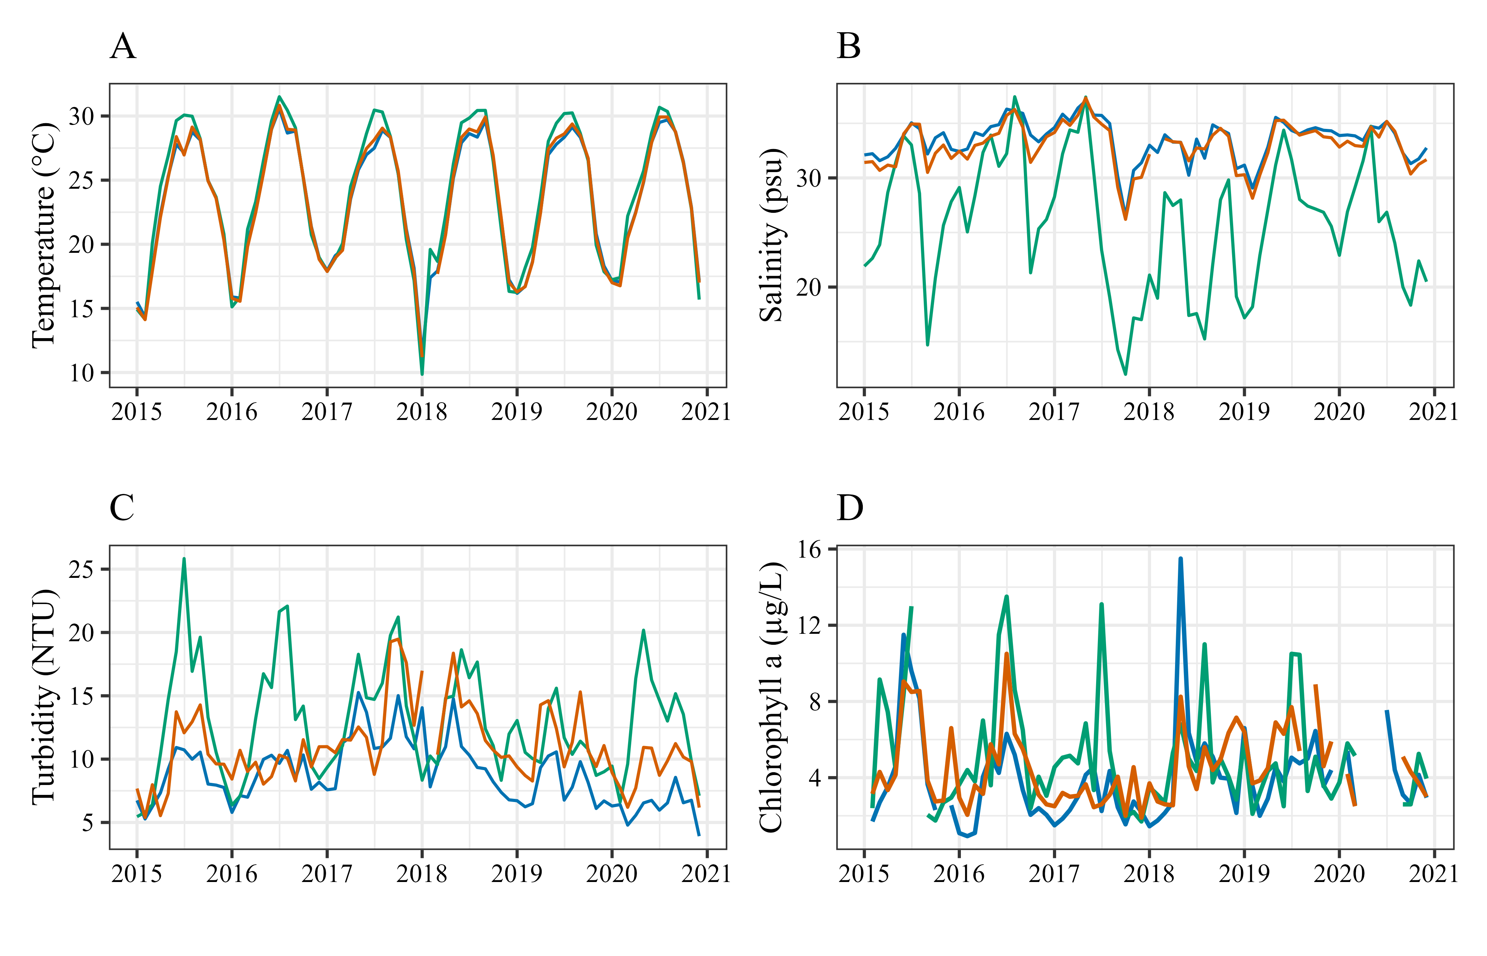

**Figure 6.** Monthly average water quality parameters at the Guana Tolomato Matanzas National Estuarine Research Reserve System-Wide Monitoring Program stations: Pine Island (PI, green), San Sebastian (SS, orange), and Fort Matanzas (FM, blue). Temperature (A), Salinity (B), and Turbidity (C) are all aggregated from 15-minute data from continuous instruments deployed at each site. Chlorophyll *a* (D) is collected monthly in duplicate at each station as a grab sample.

Monthly minimum salinities (Figure 7A) and maximum turbidity (Figure 7B) revealed more distinctive patterns between years. Minimum salinities at the more marine stations (FMWQ and SSWQ) were high during the first few years of the study, then fell below 20 PSU in the fall of 2017 and remained more variable through 2020. There was also a sharp decrease in salinity at the FMWQ station in the late summer of 2019. Spikes in turbidity maxima were observed in the fall of 2016 and 2017, and in the early spring of 2020.

Mean and maximum temperature, salinity, turbidity, and chl-*a* were higher inside the settlement period (April – October) compared to outside (January – March, November – December) at all stations (Table 4). Within the settlement period, minimum temperatures were higher and minimum salinities were lower compared to outside the settlement period (Table 4).

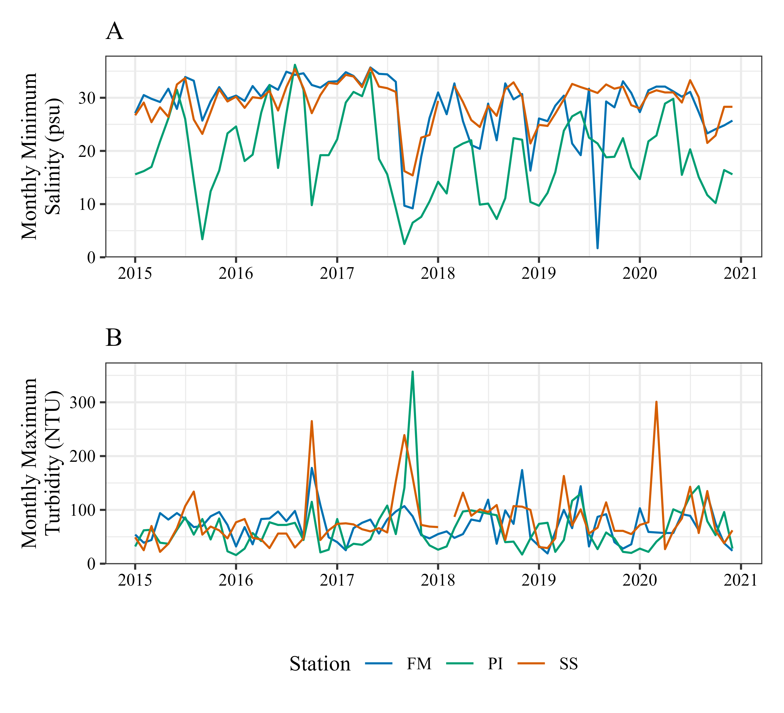

**Figure 7.** Water quality parameters at the Guana Tolomato Matanzas National Estuarine Research Reserve System-Wide Monitoring Program stations: Pine Island (PI, green), San Sebastian (SS, orange), and Fort Matanzas (FM, blue). (A) Monthly minimum salinity (PSU) and (B) monthly maximum turbidity (NTU) between 2015-2020.

**Table 4.** Summary statistics of water quality parameters inside the oyster settlement period (April – October) and outside the settlement period (January – March, November – December) from January 2015 – December 2020. Temperature (Temp., Celsius), salinity (Sal., PSU), and turbidity (Turb., NTU) statistics were calculated from 15-minute data. Chlorophyll *a* (Chl-*a*, µg/L) statistics were calculated from monthly duplicate discrete sample averages. SD = standard deviation.

|  |  |  |  |  |  |  |  |  |  |
| --- | --- | --- | --- | --- | --- | --- | --- | --- | --- |
| **Station** |  | ***Inside Settlement Period*** | | | | ***Outside Settlement Period*** | | | |
|  | **Temp** | **Sal** | **Turb** | **Chl-*a*** | **Temp** | **Sal** | **Turb** | **Chl-*a*** |
| Pine Island | Mean  SD | 27.88  2.79 | 26.34  7.74 | 15.58  7.39 | 6.07  3.42 | 18.62  3.43 | 24.57  5.33 | 9.25  3.93 | 3.88  1.51 |
| Min | 18.1 | 2.5 | 2.0 | 1.75 | 7.1 | 7.6 | 0.0 | 1.7 |
| Max | 33.7 | 38.9 | 357.0 | 13.5 | 28.7 | 35.7 | 96.0 | 9.15 |
| San Sebastian | Mean  SD | 27.04  2.83 | 33.5  2.66 | 11.76  7.14 | 5.19  2.20 | 18.45  3.08 | 32.17  2.11 | 9.71  5.82 | 3.81  1.45 |
| Min | 17.1 | 15.4 | 0.0 | 2.0 | 8.6 | 21.4 | 1.0 | 1.9 |
| Max | 33.2 | 38 | 265.0 | 10.5 | 27.5 | 36.5 | 301.0 | 7.15 |
| Fort Matanzas | Mean  SD | 26.85  2.71 | 33.84  2.61 | 9.71  6.08 | 4.88  2.68 | 18.57  3.04 | 32.87  1.97 | 7.37  4.29 | 2.66  1.34 |
| Min | 17.5 | 1.7 | 1.0 | 1.55 | 8.2 | 16.3 | 1.0 | 0.93 |
| Max | 32.9 | 38.0 | 178.0 | 15.5 | 28.1 | 36.3 | 174.0 | 6.6 |

4. Discussion

Overall, oyster settlement increased over the course of the study and peak settlement shifted from April to September. Reefs that experienced a minor peak in May as opposed to April tended to yield more spat per shell both annually and during the primary settlement period. Unfortunately, due to the severity of Hurricane Matthew, spat trees were not collected in September and October 2016 except for one tree (SA4) during September due to it being accessible by land. Except for the first year of the study (2015), all other years showed two peaks in settlement: a small peak that occurred in the spring and a large peak in September. It is unclear whether this second and high peak in settlement reflected in later years would have also been observed in 2016 given the period of missing data. In general, oysters in more southern portions of their range exhibit longer spawning periods than their more northern counterparts [43]. Peak settlement in September has been found in North Carolina [86] and North Inlet, South Carolina [51], as well as October in Sapelo Sound, Georgia [55, 56]. The length of the settlement period in this study (April – October) was like other studies in similar latitudes along the southeastern United States and Gulf of Mexico which found peaks in both spring and late summer [51, 64, 71, 87-92]. This study therefore complements previously established settlement periods, however, these previous studies include intertidal and subtidal eastern oyster reefs.

Within the GTM estuary, there were differences between regions and across years in levels of oyster settlement. The Tolomato River (TR) region consistently yielded the highest spat averages throughout the duration of this study. The TR region was established in September 2015 (seven months later than the other regions) and was initially one tree on a natural reef (TR1). Two more trees were installed in 2016 (TR2 and TR3); however, unlike trees deployed in the other regions of the project, these were deployed on the ends of a 0.3 km stretch of an enhancement project by the GTMNERR and Northeast Florida Aquatic Preserves at Wright’s Landing.

The settlement success was often higher in the trees deployed along the constructed reefs compared to the tree across the river on a natural oyster reef, leading to the high variation in the region over the course of the study. While the higher spat average at Wright’s Landing reefs could be indicative of artificial reef success, it is also possible that open exposure to water and lack of competing structure in the area influenced settlement rates as this bank of the shoreline did not have natural oyster reefs present prior to the installation of the constructed reefs. In addition to the installed artificial reef, this shoreline is also protected by a well-documented sandbar [93] that protrudes out into the river along the length of the installation. It is possible that entrapment by the sandbar may have influenced the settlement rate at these two trees.

The differential flushing, tidal, and stratification regimes across regions make comparisons across field studies difficult, all the while emphasizing the importance of place-based studies to establish patterns. Oyster larvae are relatively weak swimmers and influenced by regional circulation patterns. Differences in oyster settlement between two tributaries in the Chesapeake Bay in Maryland, USA, were found to likely be the result of different circulation patterns that exposed the less productive tributary to fewer larvae, no matter the source of their larvae [94]. In addition to the TR region, the Saint Augustine (SA) region also had high counts of spat in this study. Recent hydrodynamic studies of the GTM estuary characterized the residence times of watersheds in the estuary and the watershed in which the trees were deployed for the SA region was found to have a residence time exceeding 30 days [62]. The TR region was also found to have a relatively long residence time at 16.1 days. The longer residence times of these regions could allow for longer periods of time for the oyster larvae suspended in the water column to settle compared to regions with shorter residence times.

SA and FM were found to have some of the highest densities of oysters during the GTMNERR pilot oyster monitoring project in 2014-2016 [59] but had relatively low or the lowest spat counts during this study. Due to the quantity of oyster reefs in those regions, occupying a large spatial area, perhaps the settlement was lower on the trees given the amount of other available space for spat to settle. Oyster settlement probability has been found to be higher on larger patches of reefs, but average settler densities are often higher on smaller patches [95]. Additionally, the higher density of spat found in the TR on the constructed reef shoreline could likely resemble the effect of smaller patch reefs as they were more isolated from the natural oyster reefs in the area.

This study did not provide enough replication to quantify the effects of proximity to deep channels versus feeder creeks in oyster settlement in the GTM estuary, however there were trees deployed within the regions in both types of habitats. Some trees, like those on the TR were along the Atlantic Intracoastal Waterway (ICW) boating channel. Other trees were off navigational channels beyond the ICW (Figure 1). Oysters and mussels in the GTM estuary have been found to preferentially settle at mid to low depths in the ICW but at shallower depths in feeder creeks [96].

Boat wakes have been found to cause significant local damage and erosion of intertidal oyster reefs on the east coast of Florida where salt marshes and reefs have eroded to intertidal sand flats, impacting both established adult oysters and new recruits [14, 97-100]. The application of novel living shoreline designs to mitigate erosional effects associated with boat wakes and other high energy areas have been performed in the region with varying degrees of success but emphasize the impact of boat wakes along these shorelines [101-103]. While oyster settlement was found to increase with boating intensity in the Indian River Lagoon, FL, the finding was likely due to the increased tidal flow and potential larval supply in the boating channel rather than the boat wakes themselves [104]. More investigations into the impact of waterway traffic on oyster settlement may provide further insight into the regional patterns observed in this study, along with identifying areas in which mitigating the high energy of boat wakes will be an essential part of the design of a restoration site.

Eastern oyster spawning has been shown to be related to water temperatures, salinity [14, 105], and availability of food for adult oysters [106, 107]. Over the course of this study, there were several weather events that caused substantial environmental changes, potentially affecting settlement patterns. Three major hurricanes influenced the GTM estuary during this project. In October 2016, Category 3 Hurricane Matthew passed 40 miles offshore of St. Augustine and dropped 34.5 cm of rainfall in the area and brought 1.6 meters of storm surge [108]. The following year, Hurricane Irma (a Category 3 when it struck mainland Florida along the southwest coast) tracked up the center the state of Florida bringing large amounts of precipitation (26 cm of precipitation over St. Augustine) across the entire peninsular state in September 2017 [109]. This storm was also followed by a 5-day nor’easter in October 2017. Lastly, Hurricane Dorian followed a similar track to Hurricane Matthew in September 2019, although it remained further off the coast.

Each of these tropical cyclones was observable to some degree within the water quality data collected by the continuous monitoring stations of the GTMNERR. Most hurricane nutrient transport is driven by “wet” hurricanes with high precipitation compared to windy, dry hurricanes [110]. The most influential of the storms appears to have been Hurricane Irma, a “wet” hurricane which caused persistent changes in water quality well into the next year. It was reported that 39% of the average dissolved organic carbon, 180% annual average ammonia, and 54% annual average orthophosphate were exported from Pellicer Creek, the largest source of freshwater in the GTM estuary, during the month of Hurricane Irma [111]. This study found observable and persistent decreases in minimum salinities at all stations, particularly the more marine-influenced stations (SSWQ and FMWQ), following Hurricane Irma. Prolonged low salinity conditions, particularly coupled with warm water temperatures, can slow development, and reduce recruitment or survival for oysters at all life stages [112-114]. A decline in spat abundance was observed in 2019 in the FM region, which is most directly influenced by Pellicer Creek. This could be an indication of the negative impacts of post-hurricane water quality conditions to oyster populations.

The effects of Hurricane Irma were visible in the system for a long period of time following the storm. All stations had elevated turbidity between the second half of 2017 into the fall of 2018. In fact, the marine-influenced sites had the highest average turbidity during this period. Increased turbidity can be associated with storm-related resuspension of estuarine sediments and/or increased sediment runoff into coastal waters [115, 116]. Post-storm sediment deposits on suitable substrates can negatively affect larval settlement, recruitment, and survival [86, 117]. Dissolved inorganic nitrogen (DIN) was found to remain elevated in the Matanzas River Estuary (including the southern portion of the FM region in this study) well into January 2018 [118]. And a peak in chlorophyll a was observed at the FMWQ station in the spring of 2018, the highest observed in the entire six-year study period. Prior to this, there was also a cold snap in the beginning of January 2018 in which the coldest water temperatures were observed in the entire study period. Minimum salinities at all stations also decreased following Hurricane Irma and were low, particularly for the marine-influenced stations, well into 2019.

Overall, there appears to be evidence that environmental factors may have a direct or indirect influence on the interannual variability observed in spat settlement in the GTM estuary. In particular, the large and prolonged export of nutrients and reduction in salinity following Hurricane Irma [111, 118] the elevated spring chlorophyll *a* in 2018, and cold snap could have contributed to the increases in annual spat counts at all stations in 2017-2018 compared to 2015-2016. Annual spat production has been found to increase either directly with cumulative excess salinity over a threshold or indirectly in episodes of drought and maximum rainfall in the preceding season in Chesapeake Bay [119]. While water quality parameters may have an impact on the intertidal oysters of the GTM estuary, water quality changes may have more of an effect for subtidal oysters that may be found in other regions outside of the GTM estuary.

The cause of the highest spat abundances observed in the 2019-2020 years is unclear. Studies to directly link water quality parameters with oyster settlement will provide further insight into to the role of abiotic environmental conditions in spawning and settlement, especially if coupled with monitoring of oyster larvae presence in the water column during the deployment of spat collectors and annual patterns in density of adult oysters in the region.

Northeast Florida is an area undergoing increasing development [120], which is associated with decreased water quality conditions and increases in pollutants and sedimentation rates [121] affecting oyster populations. Coupled with the loss of oysters, upwards of 64% in the United States alone [122], and effects of erosion and a changing climate, it is likely that we’ll see more oyster habitat enhancement projects in the future. In fact, the use of living shorelines to replace or supplement hardened shorelines to create habitat and facilitate migration upslope is a recommended management priority for the state of Florida [22]. Understanding the spatial and temporal patterns of oyster settlement can help inform management to allow for informed restoration practices to maximize results, influence project design and implementation, as well as provide further information on timelines for monitoring projects for success.

5. Conclusions

Spat counts and settlement patterns in the Guana-Tolomato-Matanzas estuary matches other southeastern estuaries in that it occurs between April and October. Settlement peaked twice in the year with a small peak in the spring and the largest typically occurring in September. Inter-annual differences in oyster settlement are likely influenced by environmental conditions and heavily affected by large-scale events such as tropical cyclones. Variations in regional spat counts are likely related to residence times of the watersheds, harvesting pressure, density of adult populations, and the location of the spat collectors (proximity to deep channels and natural or artificial reef locations). Further investigation into the relationship between oyster settlement and water quality conditions can provide insight into the role of climate- and anthropogenic influences on oyster population dynamics as well as help predict oyster settlement patterns to inform oyster reef creation/enhancement projects. Results of this study illustrate region- and year-specific variability in oyster settlement patterns and underscore the importance of local monitoring for oyster resource management, restoration, and research.

**Author Contributions:** Conceptualization, S.D.K. and H.J.P.; methodology, P.M., N.D.; validation, P.M., A.K. and S.D.K.; formal analysis, S.D.K.; investigation, P.M. and N.D.; resources, A.K.; data curation, P.M. and A.K.; writing—original draft preparation, S.D.K and H.J.P.; writing—review and editing, P.M., A.K., and N.D.; visualization, S.D.K.; supervision, P.M.; project administration, N.D.; funding acquisition, N.D. All authors have read and agreed to the published version of the manuscript.

**Funding:** This research was funded by the Florida Department of Environmental Protection and the National Oceanic and Atmospheric Administration as part of annual operations for the GTMNERR.

**Data Availability Statement:** The data and analysis presented in this study are openly available in <https://github.com/skdunnigan/spat>. Water quality data from the National Estuarine Research Reserve System-Wide Monitoring Program is publicly available through the Centralized Data Management Office here: <https://cdmo.baruch.sc.edu>. Additional data on spat and oysters collected by the Guana Tolomato Matanzas National Estuarine Research Reserve are available upon request from the Research Director and corresponding author, Nikki Dix, as well as through the State of Florida Statewide Ecosystem Assessment of Coastal and Aquatic Resources Data Discovery Interface here: <https://data.florida-seacar.org/>.

**Acknowledgments:** Savanna Mathis for mapping, many staff and volunteers of the GTMNERR which include but are not limited to Benjamin Mowbray, Mathew Monroe, Shannon Rininger, Jennifer Blythe Odzinski, Remo Mondazzi, Jeff Finnan, and Mike Darragh. This research was conducted pursuant to Florida Fish and Wildlife Commission Special Activity License SAL-14-1305-SR.

**Conflicts of Interest:** The authors declare no conflicts of interest. The funders had no role in the design of the study; in the collection, analyses, or interpretation of data; in the writing of the manuscript; or in the decision to publish the results.

**Appendix A**

**Table A1.** Model results for the best-fitting generalized linear model (Table # in text) of oyster spat counts per shell on collectors deployed in five regions in the Guana Tolomato Matanzas estuary from 2015-2020 where spat count per shell = region + year + offset[log(soak time)]. Parameter estimates are on a log scale. Dispersion parameter 0.374.

|  |  |  |  |  |
| --- | --- | --- | --- | --- |
| **Parameter** | **Estimate** | **SE** | ***z*-value** | **Pr(>*z*)** |
| Intercept | -1.06 | 0.21 | -5.06 | < 0.001 |
| Guana River (GR) | -0.56 | 0.17 | -3.24 | < 0.01 |
| Saint Augustine (SA) | -0.71 | 0.17 | -4.12 | < 0.001 |
| Salt Run (SR) | -1.25 | 0.18 | -6.96 | < 0.001 |
| Fort Matanzas (FM) | -1.42 | 0.17 | -8.25 | < 0.001 |
| 2016 | 0.16 | 0.22 | 0.74 | 0.46 |
| 2017 | 0.84 | 0.21 | 4.07 | < 0.001 |
| 2018 | 1.23 | 0.21 | 5.95 | < 0.001 |
| 2019 | 1.65 | 0.2 | 8.12 | < 0.001 |
| 2020 | 1.99 | 0.21 | 9.70 | < 0.001 |

**Table A2.** Pairwise comparisons of mean spat per shell between sampled regions in the Guana Tolomato Matanzas estuary: Tolomato River (TR), Guana River (GR), Saint Augustine (SA), Salt Run (SR), and Fort Matanzas (FM). Results are averaged over the level of year and given on the log (not the response) scale. Tukey method for post-hoc tests. SE = standard error.

|  |  |  |  |  |
| --- | --- | --- | --- | --- |
| **Contrast** | **Estimate** | **SE** | ***z*-ratio** | ***p*-value** |
| TR – GR | 0.56 | 0.17 | 3.24 | 0.0105 |
| TR – SA | 0.71 | 0.17 | 4.12 | 0.0004 |
| TR – SR | 1.25 | 0.18 | 6.96 | < 0.0001 |
| TR – FM | 1.43 | 0.17 | 8.25 | < 0.0001 |
| GR – SA | 0.14 | 0.17 | 0.85 | 0.916 |
| GR – SR | 0.69 | 0.18 | 3.90 | 0.0009 |
| GR – FM | 0.86 | 0.17 | 5.12 | < 0.0001 |
| SA – SR | 0.54 | 0.18 | 3.12 | 0.0162 |
| SA – FM | 0.72 | 0.17 | 4.30 | 0.0002 |
| SR – FM | 0.18 | 0.18 | 0.998 | 0.8565 |

**Table A3.** Pairwise comparisons of mean spat per shell among sampling years in the Guana Tolomato Matanzas estuary. Results are averaged over the levels of region and given on the log (not the response) scale. Tukey method for post-hoc tests. SE = standard error.

|  |  |  |  |  |
| --- | --- | --- | --- | --- |
| **Parameter** | **Estimate** | **SE** | ***z*-value** | **Pr(>*z*)** |
| 2015 – 2016 | -0.16 | 0.22 | -0.74 | 0.9775 |
| 2015 – 2017 | -0.84 | 0.21 | -4.07 | 0.0007 |
| 2015 – 2018 | -1.23 | 0.21 | -5.95 | < 0.0001 |
| 2015 – 2019 | -1.65 | 0.20 | -8.12 | < 0.0001 |
| 2015 – 2020 | -1.99 | 0.21 | -9.70 | < 0.0001 |
| 2016 – 2017 | -0.68 | 0.19 | -3.52 | 0.0057 |
| 2016 – 2018 | -1.07 | 0.19 | -5.55 | < 0.0001 |
| 2016 – 2019 | -1.49 | 0.19 | -7.88 | < 0.0001 |
| 2016 - 2020 | -1.83 | 0.19 | -9.59 | < 0.0001 |
| 2017 – 2018 | -0.38 | 0.18 | -2.12 | 0.2745 |
| 2017 - 2019 | -0.81 | 0.18 | -4.53 | 0.0001 |
| 2017 – 2020 | -1.15 | 0.18 | -6.39 | < 0.0001 |
| 2018 - 2019 | -0.42 | 0.18 | -2.40 | 0.1572 |
| 2018 - 2020 | -0.76 | 0.18 | -4.31 | 0.0002 |
| 2019 - 2020 | -0.34 | 0.17 | -1.96 | 0.3635 |

References

1. UNEP. Marine and Coastal Ecosystems and Human Well-being: A Synthesis Report Based on the Findings of the Millennium Ecosystem Assessment; United Nations Environmental Programme: Nairobi, Kenya, pp. 76
2. Barbier, E.B. Valuing Ecosystem Services as Productive Inputs. *Economic Policy* **2007**, 22, 178–229, doi:10.1111/j.1468-0327.2007.00174.x.
3. Valiela, I.; Bowen, J.L.; York, J.K. Mangrove Forests: One of the World’s Threatened Major Tropical Environments. *BioScience* **2001**, *51*, 807, doi:[10.1641/0006-3568(2001)051[0807:MFOOTW]2.0.CO;2](https://doi.org/10.1641/0006-3568(2001)051%5b0807:MFOOTW%5d2.0.CO;2).
4. Orth, R.J.; Carruthers, T.J.B.; Dennison, W.C.; Duarte, C.M.; Fourqurean, J.W.; Heck, K.L.; Hughes, A.R.; Kendrick, G.A.; Kenworthy, W.J.; Olyarnik, S.; et al. A Global Crisis for Seagrass Ecosystems. *BioScience* **2006**, 56, 987, doi:10.1641/0006-3568(2006)56[987:AGCFSE]2.0.CO;2.
5. Ecosystems and Human Well-Being: Synthesis; Millennium Ecosystem Assessment (Program), Ed.; Island Press: Washington, DC, 2005; ISBN 978-1-59726-040-4.
6. FAO. *The State of World Fisheries and Aquaculture 2020*; FAO: Rome, Italy, 2020; ISBN 978-92-5-132692-3.
7. Beck, M.W.; Brumbaugh, R.D.; Airoldi, L.; Carranza, A.; Coen, L.D.; Crawford, C.; Defeo, O.; Edgar, G.J.; Hancock, B.; Kay, M.C.; et al. Oyster Reefs at Risk and Recommendations for Conservation, Restoration, and Management. *BioScience* 2011, 61, 107–116, doi:10.1525/bio.2011.61.2.5.
8. Worm, B.; Barbier, E.B.; Beaumont, N.; Duffy, J.E.; Folke, C.; Halpern, B.S.; Jackson, J.B.C.; Lotze, H.K.; Micheli, F.; Palumbi, S.R.; et al. Impacts of Biodiversity Loss on Ocean Ecosystem Services. *Science* **2006**, *314*, 787–790, doi:10.1126/science.1132294.
9. Scyphers, S.B.; Powers, S.P.; Heck, K.L.; Byron, D. Oyster Reefs as Natural Breakwaters Mitigate Shoreline Loss and Facilitate Fisheries. *PLoS ONE* 2011, 6, e22396, doi:10.1371/journal.pone.0022396.
10. Whalen, L.; Kreeger, D.; Bushek, D.; Moody, J.; Padeletti, A. Practioner’s Guide: Shellfish-Based Living Shorelines for Salt Marsh Erosion Control and Environmental Enhancement in the Mid-Atlantic; Partnership for the Delaware Estuary, Report #11-04, 2011; p. 48.
11. Kreeger, D.A.; Padeletti, A. Monitoring and Assessment of Representative Tidal Wetlands of the Delaware Estuary; Partnership for the Delaware Estuary, Report #13-03. 144 p.
12. Bilkovic, D. M.; Mitchell, M.M.; La Peyre, M.K.; Toft, J.D. *Living Shorelines: The Science and Management of Nature-Based Coastal Protection*, 1st ed.; CRC Press: Boca Raton, FL, USA, 2017; pp. 519. ISBN: 9780367573836
13. Brumbaugh, R.D.; Beck, M.W.; Coen, L.D.; Craig, L.; Hicks, P. A Practitioner’s Guide to the Design and Monitoring of Shellfish Restoration Projects. 2006.
14. Walters, L.J.; Donnelly, M.J.; Sacks P.; Campbell D. Lessons learned from living shoreline stabilization in popular tourist areas: boat wakes, volunteer support, and protecting historic structures. In: *Living shorelines: the science and management of nature-based coastal protection.* Bilkovic, D.M.; Mitchell, M.M.; La Peyre, M.K.; Toft, J.D., Eds.; *CRC Marine Science Series*, CRC Press, Taylor & Francis Group: Boca Raton, FL, USA, 2017, pp. 233-246.
15. Rupasinghe, M.; Nicolas, R.S.; Lanham, B.S.; Morris, R.L. Sustainable Oyster Shell Incorporated Artificial Reef Concrete for Living Shorelines. *Construction and Building Materials* **2024**, 410, 134217, doi:10.1016/j.conbuildmat.2023.134217.
16. Rodriguez, A.B.; Fodrie, F.J.; Ridge, J.T.; Lindquist, N.L.; Theuerkauf, E.J.; Coleman, S.E.; Grabowski, J.H.; Brodeur, M.C.; Gittman, R.K.; Keller, D.A.; et al. Oyster Reefs Can Outpace Sea-Level Rise. *Nature Clim Change* **2014**, *4*, 493–497, doi:10.1038/nclimate2216.
17. Gittman, R.K.; Popowich, A.M.; Bruno, J.F.; Peterson, C.H. Marshes with and without Sills Protect Estuarine Shorelines from Erosion Better than Bulkheads during a Category 1 Hurricane. *Ocean & Coastal Management* **2014**, *102*, 94–102, doi:10.1016/j.ocecoaman.2014.09.016.
18. Dame, R.F. Ecology of marine bivalves: an ecosystem approach*.* CRC Marine Science Series, Boca Raton, FL, USA, 1996, 254 pp.
19. Grabowski, J.H.; Brumbaugh, R.D.; Conrad, R.F.; Keeler, A.G.; Opaluch, J.J.; Peterson, C.H.; Piehler, M.F.; Powers, S.P.; Smyth, A.R. Economic Valuation of Ecosystem Services Provided by Oyster Reefs. *BioScience* **2012**, *62*, 900–909, doi:[10.1525/bio.2012.62.10.10](https://doi.org/10.1525/bio.2012.62.10.10).
20. Bersoza-Hernández, A.; Brumbaugh, R.D.; Frederick, P.; Grizzle, R.; Luckenbach, M.W.; Peterson, C.H.; Angelini, C. Restoring the Eastern Oyster: How Much Progress Has Been Made in 53 Years? *Frontiers in Ecol & Environ* **2018**, *16*, 463–471, doi:[10.1002/fee.1935](https://doi.org/10.1002/fee.1935).
21. Gmelin, J.F*. Systema Naturae per Regna Tria Naturae, Secundum Classes, Ordines, Genera, Species, cum Characteribus, Differentiis, Synonymis, locis.* 12th ed.; G.E. Beer, Liepzig, Germany.1791; 3021-3909.
22. Radabaugh, K.R.; Geiger, S.P.; Moyer, R.P. *Oyster Integrated Mapping and Monitoring Program Report for the State of Florida*. Florida Fish and Wildlife Research Institute: St. Petersburg, FL, USA, 2019, *Technical Report 22* pp. 175.
23. Breitburg, D.C. Are three-dimensional structure and healthy oyster populations the keys to an ecologically interesting and important fish community? pp 239-250 in Luckenbach, M.W., Mann, R., and Wesson, J.A., eds., *Oyster Reef Habitat Restoration: A Synopsis and Synthesis of Approaches*. Virginia Institute of Marine Science Press, Gloucester Pt., VA, USA, 1999; 358pp.
24. Coen, L.D.; Luckenbach, M.W. Developing Success Criteria and Goals for Evaluating Oyster Reef Restoration: Ecological Function or Resource Exploitation? *Ecological Engineering* **2000**, 15, 323–343, doi:10.1016/S0925-8574(00)00084-7.
25. Harding, J.; Mann, R.L. Influence of Habitat on Diet and Distribution of Striped Bass (Morone Saxatilis) in a Temperate Estuary. *Bulletin of Marine Science* **2003**, *72*.
26. Grabowski, J.H.; Hughes, A.R.; Kimbro, D.L.; Dolan, M.A. How Habitat Setting Influences Restored Oyster Reef Communities. *Ecology* **2005**, *86*, 1926–1935, doi:10.1890/04-0690.\
27. Tolley, S.G.; Volety, A.K. The Role of Oysters in Habitat Use of Oyster Reefs by Resident Fishes and Decapod Crustaceans. *Journal of Shellfish Research* **2005**, *24*, 1007–1012, doi:10.2983/0730-8000(2005)24[1007:TROOIH]2.0.CO;2.
28. Boudreaux, M.L.; Stiner, J.L.; Walters, L.J. Biodiversity of Sessile and Motile Macrofauna on Intertidal Oyster Reefs in Mosquito Lagoon, Florida. *Journal of Shellfish Research* **2006**, *25*, 1079–1089, doi:10.2983/0730-8000(2006)25[1079:BOSAMM]2.0.CO;2.
29. Rodney, W.S.; Paynter, K.T. Comparisons of Macrofaunal Assemblages on Restored and Non-Restored Oyster Reefs in Mesohaline Regions of Chesapeake Bay in Maryland. *Journal of Experimental Marine Biology and Ecology* **2006**, *335*, 39–51, doi:10.1016/j.jembe.2006.02.017.
30. zu Ermgassen, P.S.E.; Grabowski, J.H.; Gair, J.R.; Powers, S.P. Quantifying Fish and Mobile Invertebrate Production from a Threatened Nursery Habitat. *Journal of Applied Ecology* **2016**, *53*, 596–606, doi:[10.1111/1365-2664.12576](https://doi.org/10.1111/1365-2664.12576).
31. Nelson, K.A.; Leonard, L.A.; Posey, M.H.; Alphin, T. Using transplanted oyster (*Crassostrea virginica*) beds to improve water quality in small tidal creeks: a pilot study. *Journal of Experimental Marine Biology and Ecology* **2004**, *298(2),* 347-368, doi: [10.1016/S0022-0981(03)00367-8](https://doi.org/10.1016/S0022-0981(03)00367-8)
32. Grabowski, J.H.; Peterson, H.P. Restoring Reefs to Recover Ecosystem Services. In: *Ecosystem Engineers: Plants to Protists.* Cuddington, K., Byers, J.E., Wilson, W.G., Hastings, A., Eds.; Academic Press: Burlington, MA, USA, 2007; p. 281-298.
33. Booth, D.; Heck, K. Effects of the American Oyster *Crassostrea Virginica* on Growth Rates of the Seagrass *Halodule Wrightii*. *Mar. Ecol. Prog. Ser.* **2009**, 389, 117–126, doi:10.3354/meps08163.
34. Kellogg, M.L.; Smyth, A.R.; Luckenbach, M.W.; Carmichael, R.H.; Brown, B.L.; Cornwell, J.C.; Piehler, M.F.; Owens, M.S.; Dalrymple, D.J.; Higgins, C.B. Use of Oysters to Mitigate Eutrophication in Coastal Waters. *Estuarine, Coastal and Shelf Science* **2014**, 151, 156–168, doi:10.1016/j.ecss.2014.09.025.
35. Volety, A.K.; Haynes, L.; Goodman, P.; Gorman, P. Ecological Condition and Value of Oyster Reefs of the Southwest Florida Shelf Ecosystem. *Ecological Indicators* **2014**, *44*, 108–119, doi:10.1016/j.ecolind.2014.03.012.
36. Walles, B.; Salvador de Paiva, J.; van Prooijen, B.C.; Ysebaert, T.; Smaal, A.C. The Ecosystem Engineer Crassostrea Gigas Affects Tidal Flat Morphology Beyond the Boundary of Their Reef Structures. *Estuaries and Coasts* **2015**, 38, 941–950, doi:10.1007/s12237-014-9860-z.
37. Lunt, J.; Reustle, J.; Smee, D.L. Wave energy and flow reduce the abundance and size of benthic species on oyster reefs. *Mar. Ecol. Prog. Ser.,* **2017**, *596*, 25-36 doi:[10.3354/meps12075](https://www.int-res.com/abstracts/meps/v569/p25-36/)
38. Veenstra, J.; Southwell, M.; Dix, N.; Marcum, P.; Jackson, J.; Burns, C.; Herbert, C.; Kemper, A. High Carbon Accumulation Rates in Sediment Adjacent to Constructed Oyster Reefs, Northeast Florida, USA. *J Coast Conserv* **2021**, *25*, 40, doi:[10.1007/s11852-021-00829-0](https://doi.org/10.1007/s11852-021-00829-0).
39. Coen, L.D.; Brumbaugh, R.D.; Bushek, D.; Grizzle, R.; Luckenbach, M.W.; Posey, M.H.; Powers, S.P.; Tolley, S.G. Ecosystem Services Related to Oyster Restoration. *Marine Ecology Progress Series* **2007**, 341, 303–307, doi:10.3354/meps341303.
40. Saunders, R.; Russo, M. Coastal Shell Middens in Florida: A View from the Archaic Period. *Quaternary International* **2011**, *239*, 38–50, doi:[10.1016/j.quaint.2010.08.008](https://doi.org/10.1016/j.quaint.2010.08.008).
41. Grabowski, J.H.; Brumbaugh, R.D.; Conrad, R.F.; Keeler, A.G.; Opaluch, J.J.; Peterson, C.H.; Piehler, M.F.; Powers, S.P.; Smyth, A.R. Economic Valuation of Ecosystem Services Provided by Oyster Reefs. BioScience 2012, 62, 900–909, doi:10.1525/bio.2012.62.10.10.
42. Galstoff, P.S. The American Oyster *Crassostrea virginica* Gmelin. *Fishery Bulletin of the Fish and Wildlife Service.* **1964**, *164*, 297-380.
43. Kennedy, V.S. Biology of larvae and spat. In: *The eastern oyster: Crassostrea virginica.* Kennedy, V.S., Newell, R.I.E., Eble, A.F., Eds.; Maryland Sea Grant College: College Park, MD, USA, 1996; p. 371-421.
44. Nelson, T.C.; Perkins, E.B. Annual report of the Department of Biology for the year ending June 30, 1930. **1931**, N. *J. Agr. Exp. Sta.* p. 1-47.
45. Nelson, T.C. Observations of the behavior and distribution of oyster larvae. *Proc. Natl. Shellfish. Assoc.* **1953**, 43, 99-104.
46. Kennedy, V.S. Comparison of recent and past patterns of oyster settlement and seasonal fouling in Broad Creek and Tred Avon River, Maryland. *Pro. Natl. Shellfish. Assoc.* **1980**, *70*, 36-46.
47. Underwood, A.J.; Fairweather, P.G. Supply-Side Ecology and Benthic Marine Assemblages. *Trends in Ecology & Evolution* **1989**, *4*, 16–20, doi:10.1016/0169-5347(89)90008-6.
48. Michener, W.K.; Kenny, P.D. Spatial and Temporal Patterns of Crassostrea Virginica (Gmelin) Recruitment: Relationship to Scale and Substratum. *Journal of Experimental Marine Biology and Ecology* **1991**, *154*, 97–121, doi:10.1016/0022-0981(91)90077-A.
49. Hoese, H. D.; Nelson, W. R.; Beckert, H. Seasonal and spatial setting of fouling organisms in Mobile Bay and eastern Mississippi Sound, Alabama. *Alabama Marine Resources Bulletin* **1972**, *8*, 9-17.
50. Lee, C. Seasonal and spatial study of oyster spat in Mobile Bay and East Mississippi Sound. PhD Dissertation, University of South Alabama, Mobile, AL, 1979.
51. Kenny, P.D.; Michener, W.K.; Allen, D.M. Spatial and temporal patterns of oyster settlement in a high salinity estuary. *J. Shellfish Res.* **1990**, *9*, 133-140.
52. Saoud, I.G.; Rouse, D.B.; Wallace, R.K.; Howe, J.; Page, B. Oyster Crassostrea Virginica Spat Settlement as It Relates to the Restoration of Fish River Reef in Mobile Bay, Alabama. *Journal of the World Aquaculture Society* **2000**, *31*, 640–650, doi:10.1111/j.1749-7345.2000.tb00914.x.
53. Kim, C.; Park, K.; Powers, S.P.; Graham, W.M.; Bayha, K.M. Oyster Larval Transport in Coastal Alabama: Dominance of Physical Transport over Biological Behavior in a Shallow Estuary. *J. Geophys. Res.* **2010**, *115*, 2010JC006115, doi:10.1029/2010JC006115
54. Ingle, R.M.; Dawson, Jr., C.E. Growth of the American Oyster, *Crassostrea virginica* (Gmelin) in Florida Waters. *Bulletin of Marine Science* **1952,** *2*, 393-404.
55. O’Beirn, F.X.; Heffernan, P.B.; Walker, R.L. Recruitment of the eastern oyster in coastal Georgia: patterns and recommendations*. North American Journal of Fisheries Management*, **1996**, *16*, pp. 413-426
56. O’Beirn, F.X.; Heffernan, P.B.; Walker, R.L.; Jansen, M.L. Young-of-the-Year Oyster, *Crassostrea virginica*, Reproduction in Coastal Georgia. *Estuaries*, **1996**, *19(3),* 651-658
57. Pine, W.E.; Brucker, J.; Davis, M.; Geiger, S.; Gandy, R.; Shantz, A.; Stewart Merrill, T.; Camp, E.V. Collapsed Oyster Populations in Large Florida Estuaries Appear Resistant to Restoration Using Traditional Cultching Methods—Insights from Ongoing Efforts in Multiple Systems. *Mar Coast Fish* **2023**, *15*, e10249, doi:[10.1002/mcf2.10249](https://doi.org/10.1002/mcf2.10249).
58. Dix, N. G. How Estuaries Respond to Nutrient Load: The Guana Tolomato Matanzas National Estuarine Research Reserve as a Model Case. National Estuarine Research Reserve Graduate Research Fellowship Final Report, 2009.
59. Marcum, P.; Dix, N.; Monroe, M. Guana Tolomato Matanzas National Estuarine Research Reserve 2014-2016 Oyster Monitoring Summary; Guana Tolomoto Matanzas National Estuarine Research Reserve, **2018**; p. 32.
60. Phlips, E.J.; Love, N.; Badylak, S.; Hansen, P.; Lockwood, J.; John, C.V.; Gleeson, R. A Comparison of Water Quality and Hydrodynamic Characteristics of the Guana Tolomato Matanzas National Estuarine Research Reserve and the Indian River Lagoon of Florida. *J. Coast. Res.* **2004**, *SI 45*, 93-109. doi:[10.2112/SI45-093.1](https://doi.org/10.2112/SI45-093.1).
61. Sheng, Y.P.; Tutak, B.; Davis, J.R.; Paramygin, V. Circulation and Flushing in the Lagoonal System of the Guana Tolomato Matanzas National Estuarine Research Reserve (GTMNERR), Florida. *J. Coast. Res.* **2008**, *10055*, 9-25. doi:[10.2112/SI55-002.1](https://doi.org/10.2112/SI55-002.1)
62. Gray, M.W.; Pinton, D.; Canestrelli, A.; Dix, N.; Marcum, P.; Kimbro, D.; Grizzle, R. Beyond Residence Time: Quantifying Factors that Drive the Spatially Explicit Filtration Services of and Abundant Native Oyster Population. *Estuaries and Coasts*. **2022**, *45*, 1343–1360, doi:[10.1007/s12237-021-01017-x](https://doi.org/10.1007/s12237-021-01017-x).
63. NOAA National Estuarine Research Reserve System (NERRS). System-Wide Monitoring Program. Centralized Data Management Office. Available on <https://cdmo.baruch.sc.edu> (accessed on 31 January 2024)
64. Arnold, W.S.; Parker, M.L.; Stephenson, S.P. Oyster monitoring in the northern estuaries. St. Petersburg, FL: Florida Fish & Wildlife Research Institute. 2008
65. Metz, J.L.; Stoner, E.W.; Arrington, D.A. Comparison of substrates for Eastern Oyster (*Crassostrea virginica*) spat settlement in the Loxahatchee River estuary, Florida. *J. of Shel. Res.* **2015**, *34(3)*, 861-865.
66. Parker, M.L.; Arnold, W.S.; Geiger, S.P.; Gorman, P.; Leone, E.H. Impacts of Freshwater Management Activities on Eastern Oyster (Crassostrea Virginica) Density and Recruitment: Recovery and Long-Term Stability in Seven Florida Estuaries. *J. of Shel. Res.* **2013**, *32*, 695–708, doi:10.2983/035.032.0311.
67. Southworth, M.; Mann, R. Decadal scale changes in seasonal patterns of oyster recruitment in the Virginia sub estuaries of the Chesapeake Bay. *J. of Shel. Res.* **2004**, *23*, 291-402
68. Volety, A.K.; Savarese, M.; Tolley, S.G.; Arnold, W.S.; Sime, P.; Goodman, P.; Chamberlain, R.H.; Doering, P.H. Eastern Oysters (*Crassostrea Virginica*) as an Indicator for Restoration of Everglades Ecosystems. *Ecological Indicators* **2009**, *9*, S120–S136, doi:10.1016/j.ecolind.2008.06.005.
69. Haven, D.S.; Fritz, L.W. Settling of the American oyster *Crassostrea virginica* in the James River, Virginia, USA: temporal and spatial distribution. *Marine Biology* **1985**, *86*, 271-282.
70. Parker, M.L. Oyster Monitoring in the Northern Estuaries on the Southeast Coast of Florida, *Florida Fish and Wildlife Research Institute Final Report (2005-2014),* 2015.
71. Volety, A.K.; Savarese, M. Oysters as indicators of ecosystem health: determining the impacts of watershed alterations and implications for restoration. *Final Report submitted to National Life Foundation, South Florida Water Management District (Big Cypress Basin), and Florida Gulf Coast University Foundation*. 2001.
72. Wilson, C.; Scotto, L.; Scarpa, J.; Volety, A.; Laramore, S.; Haunert, D. Survey of Water Quality, Oyster Reproduction and Oyster Health Status in the St. Lucie Estuary. *J. Shellfish Res.* **2005**, 24, 157–165, doi:10.2983/0730-8000(2005)24[157:SOWQOR]2.0.CO;2.
73. NOAA National Estuarine Research Reserve System (NERRS). System-Wide Monitoring Program Data Management Manual, v6.7. Centralized Data Management Office **2022**, 201. <https://cdmo.baruch.sc.edu>
74. Rice, E.W.; Baird, R.B.; Eaton, A.D.; Clesceri, L.S. 10200 Chlorophyll. In Standard Methods For The Examination of Water and Wastewater; American Public Health Association, American Water Works Association, Water Environment Federation: Port City Press, Baltimore, Maryland, 2012; p. 1496 ISBN 978-0-87553-013-0.
75. R Core Team. R: A Language and Environment for Statistical Computing. R Foundation for Statistical Computing: Vienna, Austria, 2023 (<https://www.R-project.org/>)
76. Beck, M.W. SWMPr: An R Package for Retrieving, Organizing, and Analyzing Environmental Data for Estuaries. *The R Journal* **2016***, 8,* 219-232. doi: [10.32614/RJ-2016-015](https://doi.org/10.32614/RJ-2016-015)
77. Moore, J.F.; Pine, W.E.; Frederick, P.C.; Beck, S.; Moreno, M.; Dodrill, M.J.; Boone, M.; Sturmer, L.; Yurek, S. Trends in Oyster Populations in the Northeastern Gulf of Mexico: An Assessment of River Discharge and Fishing Effects over Time and Space. *Mar Coast Fish* **2020**, *12*, 191–204, doi:[10.1002/mcf2.10117](https://doi.org/10.1002/mcf2.10117).
78. Zuur, A.F.; Hilbe, J.M.; Ieno, E.N. *A Beginner’s Guide to GLM and GLMM with R: A Frequentist and Bayesian Perspective for Ecologists*; Highland Statistics Ltd. book series; Highland Statistics Limited, **2013**; ISBN 978-0-9571741-3-9.
79. Burnham, K.P.; Anderson, D.R. Model Selection and Multimodel Inference: A Practical Information-Theoretic Approach; 2nd ed.; Springer: New York, NY, USA, 2002; pp. 488 ISBN 978-0-387-95364-9.
80. Brooks, M.E.; Kristensen, K.; van Benthem, K.J.; Magnusson, A.; Berg, C.W.; Nielsen, A.; Skaug, H.J.; Maechler, M.; Bolker, B.M. glmmTMB Balances Speed and Flexibility Among Packages for Zero-Inflated Generalized Linear Mixed Modeling. *The R Journal* **2017**, *9*, 378–400, doi:[10.32614/RJ-2017-066](https://doi.org/10.32614/RJ-2017-066).
81. Lüdecke, D.; Ben-Shachar, M.S.; Patil, I.; Waggoner, P.; Makowski, D. performance: An R Package for Assessment, Comparison and Testing of Statistical Models. *The J. of Open Source Sci.* **2021**, 6(60), 3139. doi: [10.21105/joss.03139](https://doi.org/10.21105/joss.03139)
82. Hartig, F. DHARMa: Residual Diagnostics for Hierarchical (Multi-Level/Mixed) Regression Models. [R Package DHARMa Version 0.4.6]. Available online: <https://CRAN.R-project.org/package=DHARMa> (accessed on 02 February 2024)
83. Lenth, R. emmeans: Estimated Marginal Means, Aka Least-Squares Means. [R Package emmeans Version 1.10.0]. Available online: <https://CRAN.R-project.org/package=emmeans> (accessed on 02 February 2024)
84. Wickham, H. *ggplot2: Elegant Graphics for Data Analysis*. Springer-Verlag: New York, NY, USA. **2016**; ISBN: 978-3-319-24277-4
85. Wickham, H.; François, R.; Henry, L.; Müller, K.; Vaughan, D. dplyr: A Grammar of Data Manipulation. [R Package dplyr Version 1.1.4]. Available online: <https://CRAN.R-project.org/package=dplyr> (accessed on 02 February 2024)
86. Ortega, S.; Sutherland, J.P. Recruitment and growth of the eastern oyster, *Crassostrea virginica*, in North Carolina. *Estuaries*, **1992**, *15*, 158-170
87. Moore and Trent 1971 Moore, D.; Trent, L. Setting, growth and mortality of *Crassostrea virginica* in a natural marsh and a marsh altered by a housing development. *Proc. Natl. Shellfish. Assoc.*, **1971*,*** *61*, 51-58.
88. Ingle, R.M. Spawning and Setting of Oysters in Relation to Seasonal Environmental Changes. *Bulletin of Marine Science* **1951**, *1*, 111–135.
89. Butler, P.A. Reproductive cycle in native and transplanted oysters. *Proc. Natl. Shellfish Assoc.* **1956**, *46*, 75-81.
90. Manley, J.; Power, A.; Walker, R. Patterns of Eastern Oyster, *Crassostrea virginica* (Gmelin, 1791), Recruitment in Sapelo Sound, Georgia: Implications for Commercial Oyster Culture. *Occasional Papers of the University of Georgia Marine Extension Service*, **2008**, *3* pp. 20. Available online: <https://repository.library.noaa.gov/view/noaa/35158/noaa_35158_DS1.pdf>
91. Parker, M.L.; Arnold, W.S.; Geiger, S.P; Gorman, P.; Leone, E.H. Impact of freshwater management activities on Eastern Oyster (*Crassostrea virginica*) density and recruitment: recovery and long-term stability in seven Florida estuaries. Journal of Shellfish Research, **2013**, *32(3)*, 695-708.
92. Wilson, C.; Scotto, L.; Scarpa, J.; Volety, A. ; Laramore, S.; Hauernert, D. Survey of water quality, oyster reproduction and oyster health status in the St. Lucie Estuary. *J. Shellfish Res***.****2005**, *24*, 157-165.
93. Meide, C.; Turner, S. P.; Burke, B.P. 2007-2009 Investigations at the Tolomato Bar Anchorage, 8SJ3150 and 8SJ4801. *First Coast Maritime Archaeology Project 2007-2009: Report on Archaeological and Historical Investigations and Other Project Activities*, 2nd ed.; Lighthouse Archaeological Monitoring Program, Inc., **2010**: Saint Augustine, Florida, USA; pp. 259-291
94. Kennedy, V.S.; Krantz, L.B. Comparative Gametogenic and Spawning Patterns of the Oyster *Crassostrea virginica* (Gmelin) in Central Chesapeake Bay. *Journal of Shellfish Research* **1982**, 2, 133–140.
95. Fuchs, H.L.; Reidenbach, M.A. Biophysical Constraints on Optimal Patch Lengths for Settlement of a Reef-Building Bivalve. *PLoS ONE* **2013**, 8, e71506, doi:10.1371/journal.pone.0071506.
96. Raabe, J.M.; Gilg, M.R. Native and Nonnative Bivalve Settlement: Potential Competition for Spatial Resources in a Northeast Florida Estuary. *Journal of Molluscan Studies* **2020**, *86*, 372–381, doi:[10.1093/mollus/eyaa019](https://doi.org/10.1093/mollus/eyaa019).
97. Grizzle, R.E.; Adams, J.R.; Walters, L.J. Historical changes in intertidal oyster (*Crassostrea virginica*) reefs in a Florida Lagoon potentially related to boating activities. *J. of Shel. Res.* **2002**, *21*, 749-756
98. Wall, L.M.; Walters, L.J.; Grizzle, R.E.; Sacks, P.E. Recreational Boating Activity and its Impact on the Recruitment and Survival of the Oyster *Crassostrea virginica* on Intertidal Reefs in Mosquito Lagoon, Florida. *J. of Shel. Res.* **2005**, *24(4),* 965-973
99. Price, F.D.; Quantification, Analysis, and Management of Intracoastal Waterway Channel Margin Erosion in the Guana Tolomato Matanzas National Estuarine Research Reserve, Florida. Master of Science, Florida State University, Tallahassee, FL, USA, March 29, 2005.
100. Dix, N.; Walters, L.; Hernandez, E.; Roddenberry, A.; Garvis, S.; Anderson, M.; Radabaugh, K.R. Northeast Florida. In *Oyster Integrated Mapping and Monitoring Program Report for the State of Florida*; Radabaugh, K.R.; Geiger, S.P.; Moyer, R.P., Eds.; Florida Fish and Wildlife Research Institute: St. Petersburg, FL, USA, 2019; *Technical Report 22* pp. 143-159.
101. Herbert, D.; Astrom, E.; Bersoza, A.; Batzer, A.; McGovern, P.; Angelini, C.; Wasman, S.; Dix, N.; Sheremet, A. Mitigating Erosional Effects Induced by Boat Wakes with Living Shorelines. *Sustainability* **2018**, *10*, 436, doi:[10.3390/su10020436](https://doi.org/10.3390/su10020436).
102. Safak, I.; Angelini, C.; Sheremet, A. Boat Wake Effects on Sediment Transport in Intertidal Waterways. *Continental Shelf Research* **2021**, *222*, 104422, doi:[10.1016/j.csr.2021.104422](https://doi.org/10.1016/j.csr.2021.104422).
103. Mathews, H.; Uddin, M.J.; Hargis, C.W.; Smith, K.J. First-Year Performance of the Pervious Oyster Shell Habitat (POSH) along Two Energetic Shorelines in Northeast Florida. *Sustainability* **2023**, *15*, 7028, doi:[10.3390/su15097028](https://doi.org/10.3390/su15097028).
104. Sussan, T.T.; Charpentier, C.L. Conditions That Promote Oyster Settlement Coincide with Areas of High Boating Activity in a Developed Coastal Habitat. *Journal of Experimental Marine Biology and Ecology* **2024**, *572*, 151989, doi:[10.1016/j.jembe.2024.151989](https://doi.org/10.1016/j.jembe.2024.151989).
105. Butler, P.A. Gametogenesis in the oyster under conditions of depressed salinity. The Biol. Bull. 1949, 96, 263-269.
106. Hofmannn, E.E.; Klinck, J. Modeling oyster populations. III. Critical feeding periods, growth and reproduction. *Journal of Shellfish Research* **1992**, *11*, 399-416.
107. Dekshenieks, M.M.; Hofmann, E.E.; Powell, E.N. Environmental Effects on the Growth and Development of Eastern Oyster, Crassostrea Virginica (Gmelin, 1791), Larvae: A Modeling Study. *Journal of Shellfish Research* **1993**, *12*, 241–254.
108. Stewart, S.R. Hurricane Matthew; National Hurricane Center: Miami, FL, USA, 2016.
109. Cangialosi, J.P.; Latto, A.S.; Berg, R. National Hurricane Cetner Tropical Cyclone Report; National Hurricane Center: Miami, FL, USA, 2018.
110. Paerl, H.W.; Crosswell, J.R.; Van Dam, B.; Hall, N.S.; Rossignol, K.L.; Osburn, C.L.; Hounshell, A.G.; Sloup, R.S.; Harding, L.W., Jr. Two Decades of Tropical Cyclone Impacts on North Carolina’s Estuarine Carbon, Nutrient and Phytoplankton Dynamics: Implications for Biogeochemical Cycling and Water Quality in a Stormier World. *Biogeochemistry* **2018**, *141*, 307-332 doi: 10.1007/s10533-018-0438-x
111. Schafer, T.; Dix, N.; Dunnigan, S.; Reddy, K.R.; Osborne, T.Z. Impacts of Hurricanes on Nutrient Export and Ecosystem Metabolism in a Blackwater River Estuary Complex. JMSE 2022, 10, 661, doi:[10.3390/jmse10050661](https://doi.org/10.3390/jmse10050661)
112. La Peyre, M.K.; Eberline, B.S.; Soniat, T.M.; La Peyre, J.F. Differences in Extreme Low Salinity Timing and Duration Differentially Affect Eastern Oyster (Crassostrea Virginica) Size Class Growth and Mortality in Breton Sound, LA. *Estuarine, Coastal and Shelf Science* **2013**, *135*, 146–157, doi:10.1016/j.ecss.2013.10.001.
113. Pruett, J. L.; Pandelides, A. F.; Willett, K. L.; Gochfeld, D. J. Effects of flood-associated stressors on growth and survival of early life stage oysters (Crassostrea virginica). *Journal of Experimental Marine Biology and Ecology*, **2021,** *544*, 151615.
114. Rybovich, M.; La Peyre, M. K.; Hall, S. G.; La Peyre, J. F. Increased temperatures combined with lowered salinities differentially impact oyster size class growth and mortality. *Journal of Shellfish Research*, **2016**, *35*, 101-113.
115. Vidon, P.; Karwan, D. L.; Andres, A. S.; Inamdar, S.; Kaushal, S., Morrison, J.; ... Yoon, B. In the path of the Hurricane: impact of Hurricane Irene and Tropical Storm Lee on watershed hydrology and biogeochemistry from North Carolina to Maine, USA. *Biogeochemistry*, **2018,** *141*, 351-364.
116. Yellen, B.; Woodruff, J. D.; Kratz, L. N.; Mabee, S. B.; Morrison, J.; Martini, A. M. Source, conveyance and fate of suspended sediments following Hurricane Irene. New England, USA. *Geomorphology*, **2014**, *226*, 124-134.
117. Poirier, L. A.; Clements, J. C.; Coffin, M. R.; Craig, T.; Davidson, J.; Miron, G.; ...Comeau, L. A. Siltation negatively affects settlement and gaping behaviour in eastern oysters. *Marine Environmental Research* **2021**, *170*, 105432.
118. Brown, M.T.; Dix, N.; Osborne, T.; Castle, A.; Woodward, W.; Hartnett, A.; Dunnigan, S.; Tanner, S.; McGinley, E. The Impacts of a Restoration Dredging Project and Storm Events on Water Quality in a Northeast Florida Barrier Island Estuary. *Journal of Coastal Research* **2023**, *39*, doi:[10.2112/JCOASTRES-D-22-00070.1](https://doi.org/10.2112/JCOASTRES-D-22-00070.1).
119. Ulanowicz, R. E.; Caplins, W.C.; Dunnington, E.A. The Forecasting of Oyster Harvest in Central Chesapeake Bay. *E and C Mar. Sci.* **1980**, *2*: 101-106.
120. Kyzar, T.; Safak, I.; Cebrian, J.; Clark, M.W.; Dix, N.; Dietz, K.; Gittman, R.K.; Jaeger, J.; Radabaugh, K.R.; Roddenberry, A.; et al. Challenges and Opportunities for Sustaining Coastal Wetlands and Oyster Reefs in the Southeastern United States. *Journal of Environmental Management* **2021**, *296*, 113178, doi:[10.1016/j.jenvman.2021.113178](https://doi.org/10.1016/j.jenvman.2021.113178).
121. Frazel, D.W. Site Profile of the Guana Tolomato Matanzas National Estuarine Research Reserve. Ponte Vedra, FL, USA; 2009, 151pp.
122. Zu Ermgassen, P.S.E.; Spalding, M.D.; Blake, B.; Coen, L.D.; Dumbauld, B.; Geiger, S.; Grabowski, J.H.; Grizzle, R.; Luckenbach, M.; McGraw, K.; et al. Historical Ecology with Real Numbers: Past and Present Extent and Biomass of an Imperiled Estuarine Habitat. *Proc. R. Soc. B*. **2012**, *279*, 3393–3400, doi:[10.1098/rspb.2012.0313](https://doi.org/10.1098/rspb.2012.0313).